Lab 2 - Dom Tree Navigation

## Learning Goals

* HTML Events
* DOM Tree
* Tree Traversals

## Helpful links:

<http://www.w3schools.com/jsref/dom_obj_event.asp>

<http://www.w3schools.com/jsref/dom_obj_all.asp>

<https://en.wikipedia.org/wiki/Tree_traversal#Depth-first_search>

<https://en.wikipedia.org/wiki/Depth-first_search>

## Lab Overview and Reqirements

The goal of this lab is to navigate the DOM tree by clicking on elements.  When an element is clicked, you should display the next actual element in the DOM Tree, using a depth first search. The navigation route should skip over scripts and not get caught in infinite loops (have a single, repeatable path through the tree). Clicking the last element will return to the first clickable (not <head>) element.

Specifically, when you click on an element, you should signify that the element was clicked and display the next element to the console.

Some ways to signify:

* + Change to a random color (easier)
  + Fade in or out (harder)

You must create the formatting for the page. Expand upon the above examples as css stubs if you wish, but the page must be unique to you, and must include:

* All elements with borders
* Several nested children
* Several siblings
* At least one of each of the following:
  + div, p, ul or ol, li, span

Additionally, you must have

* External JavaScript code
  + Correctly tabbed
  + Well named variables
* External CSS styling
  + Multiple colors

Example code:

*... <!-- other code -->*

<body id='a' class="fadeIn" onclick="highlight()">

<div class="location">

Zoo

<div class="animal">

Gi<span>raf</span>fe

<div>Ga</div>

<div>Gb</div>

<div>Gc</div>

<div>Gd</div>

<div>Ge</div>

</div>

</div>

</body>

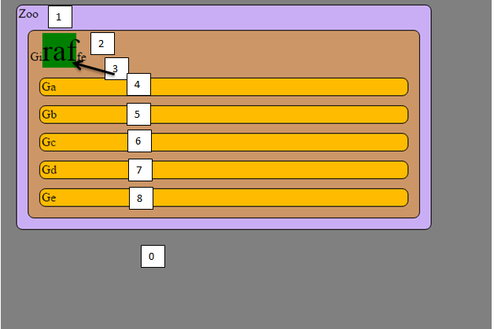

When you click on item x, it will highlight item (x+1)%9. That is, clicking on any element will highlight the next item, and clicking on the last item will highlight the first.